# Lab 4

**Prototyping with Evolus Pencil (V 3.0.4)**

**Note:**

This prototyping lab is ahead of the lecture content by one week, and I apologise for the ‘unusual thematic continuity’! The reason I will explain in lecture time.

**Exercise 1**

**Functional Prototypes**

A functional prototype is an interactive prototype that demonstrates aspects of a proposed interface design. Various technologies may be used to create interactive prototypes, including PowerPoint and various Open-Source and Web-based technologies. A functional prototype may be used to test a conceptual design for an interface.

The key point about creating interactive prototypes is that any application that allows ***hypertext linking*** may be used to create interactive prototypes. You need to be familiar with this concept as you will be expected to create a functional interactive prototype as part of the module assignment later on.

**Lab 4 – Prototyping with Evolus Pencil (V3.0.4)**

As you saw last week any application that allows hypertext linking may be used to create an interactive prototype. In this lab you will use the open-source GUI prototyping tool Evolus Pencil to re-create the interactive demo from last week’s lecture.

* There are two parts to today’s lab. You will create a Pencil File for Part 1 and a MS Word file for Part 2 of this Lab. You will Zip the 2 documents into 1 Zip file and upload them when finished the Lab. See the end of this lab sheet for full details.
* **Save your lab work periodically to a USB, or to your own account.**
* Demonstrate your completed lab work to the Lecturer or Lab Supervisor before you leave the Lab today.
* Upload the Zip file of your completed lab work to WebCourses before you leave the Lab today to ensure there is a record of your work.

Pencil is on all the Lab computers. Click the Icon on the Desktop. Pencil is free Open-Source software. You can also download a copy and install Pencil on your own computer. Download from here <http://pencil.evolus.vn/>Read about the features of Pencil here <http://pencil.evolus.vn/Features.html> . Pencil provides various collections of user interface ‘widgets’ in its left-hand panel, e.g. Basic Web Elements, Desktop GUI widgets, and Mobile GUI widgets, (Android and IPhone).

**Creating a Functional Prototype using Pencil**

**Before you begin:** Create a folder in your Account (or USB) named ‘*Pencil-Prototype’*. Pencil exports a number of files and folders for prototypes. You will export them to the ‘*Pencil-Prototype’* folder. This makes it easier to find and ‘run’ the prototype later.

**Launch Pencil**: Save the Pencil File as *lab4-part1-studentNumber.epgz*  
*e.g. lab4-part1-C1234567.epgz* (Save to your *Pencil-Prototype’ folder in* Account or USB).

Create four pages named ‘Home’, ‘About’,’ ‘Events’, and ‘Contact’. Put buttons on the pages to allow interactivity between the pages. Create the interactions by linking the buttons to their destination pages. The links you define will be converted to HTML hyper-links when you export your prototype as a web page to test your prototype’s interactivity.

**1. Create four pages in Pencil named ‘Home’, ‘About’,’ ‘Events’, and ‘Contact’.**

1.0 Create a New Document using **Ctrl-N**.

1.1 Rename Untitled Page as **Home** page. Page Size = Normal Web Page.

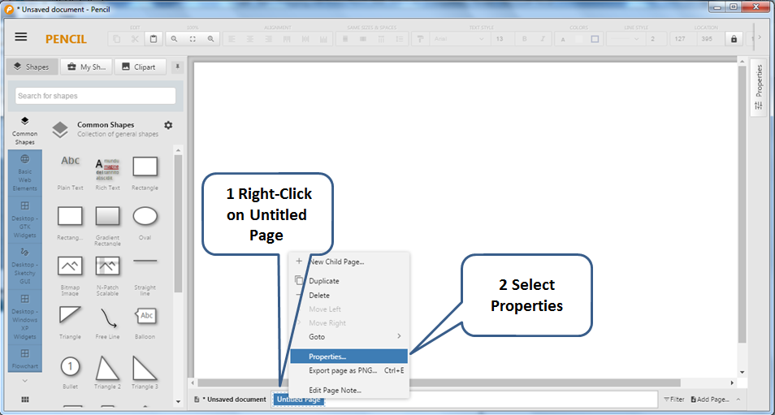

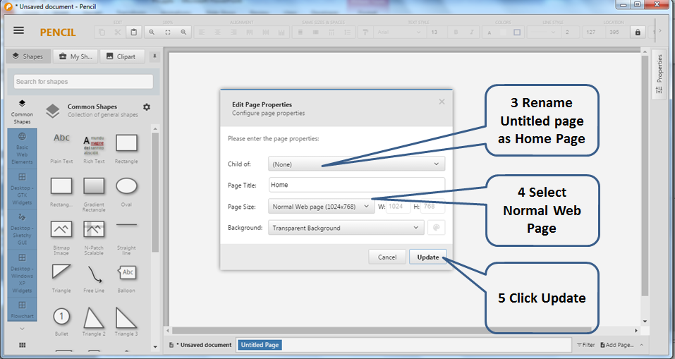

1.2 Add a New Page and name it **About** page.

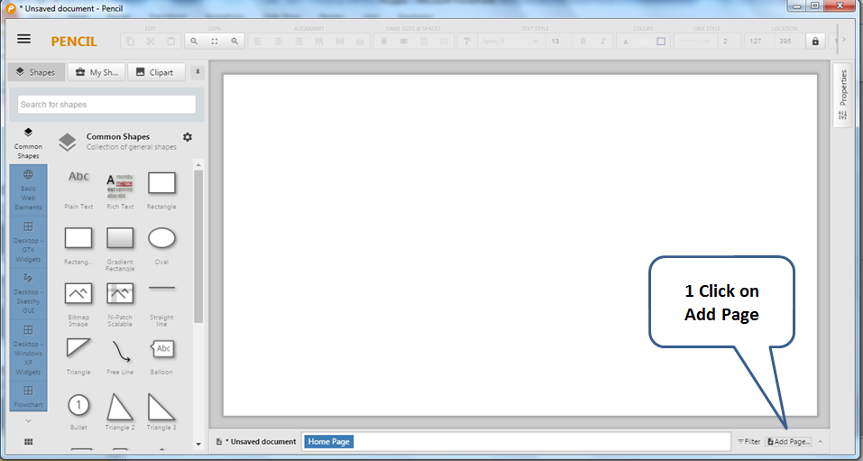

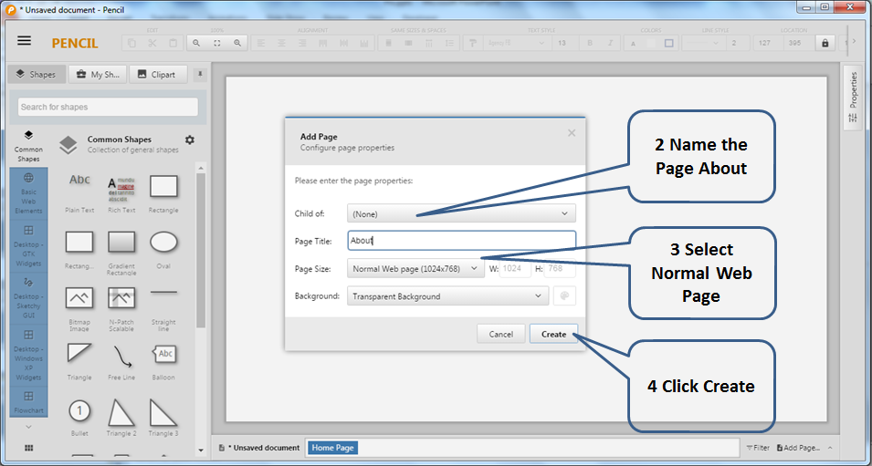

1.4 Zoom out with the Zoom tools (or Ctrl ‘-’, Ctrl ‘+’) & Show full page area,

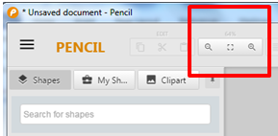

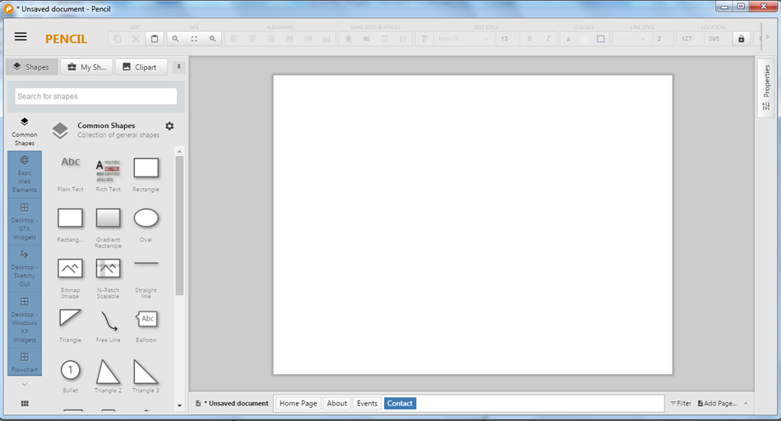

1.5 Repeat the above steps and add New Pages named **Events,** and **Contact**

.

**2. Put a Title on the Home Page and repeat for each of the other pages.**

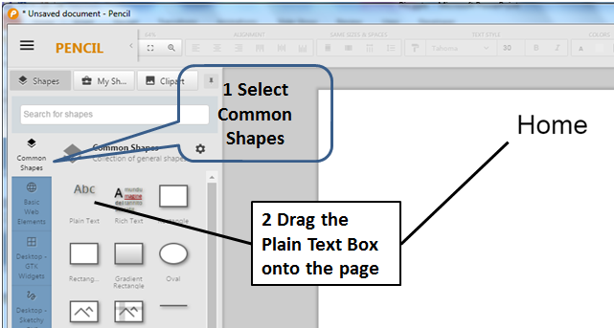

**3. Put Buttons on the Home Page and label them.**

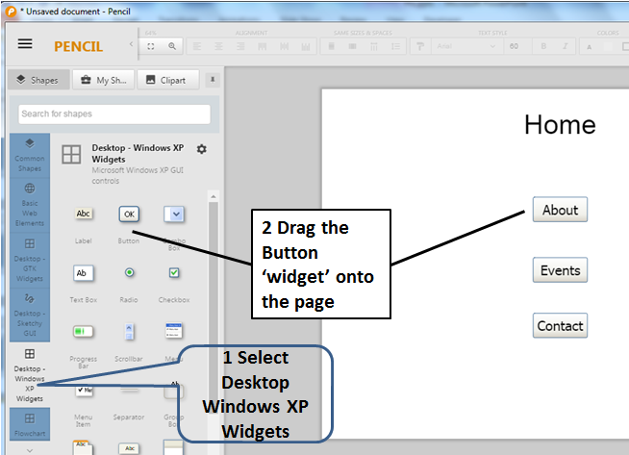

**4. Put a ‘Home’ Button on the other pages using the Button ‘widget’ as done in Step 3.**

**5. Create the interactions by linking the buttons to their destination pages.**

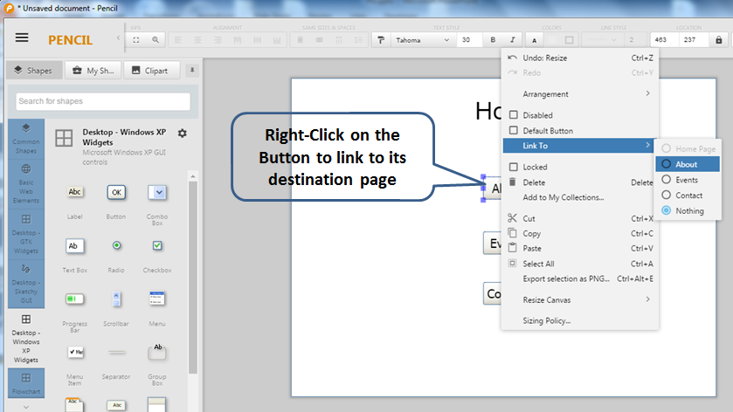

5.1 Right-Click on each Button and link that Button its destination page.

5.2 Repeat Step 5.1 for **Home** buttons on the other pages.

5.3 Save the Pencil File as *lab4-part1-studentNumber.epgz*

**6. Export your prototype as a Web page to test the interactivity.**

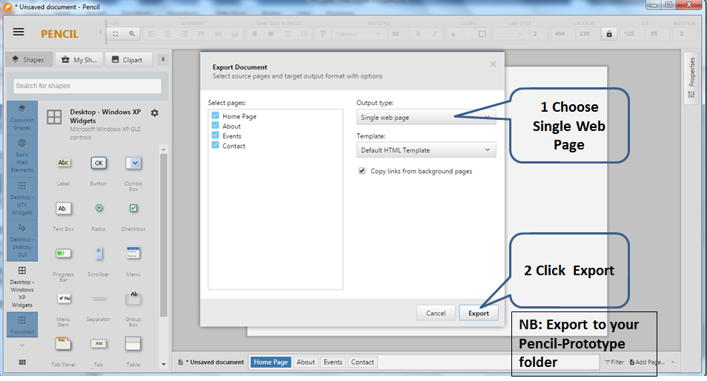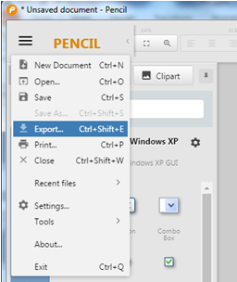

**NB: Very Important Ensure you select the ‘*Pencil-Prototype’* folder that you created at the start of this Lab. Pencil exports a number of files and folders for prototypes. They all need be together in the one place. This makes it easier to find and ‘run’ the prototype.**

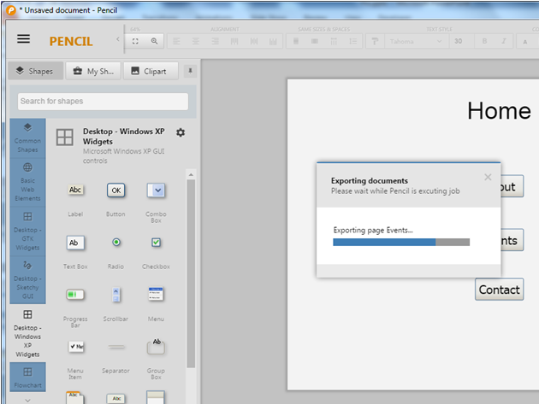

Pencil exports your prototype as web page (plus two folders named pages, and resources). The hyperlinks on the web page provide the interactivity. See the next section.

**7. ‘Run’ and Test the Prototype**

7.1 Go to your *Pencil-Prototype folder.*

7.2 Launch the file named ‘index.html’. This is your interactive prototype.

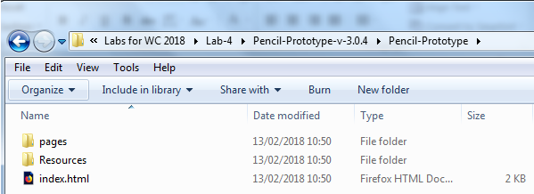

7.3 Test the Interaction.

Does the interaction work as planned? If not, recheck link creation in Section 5.

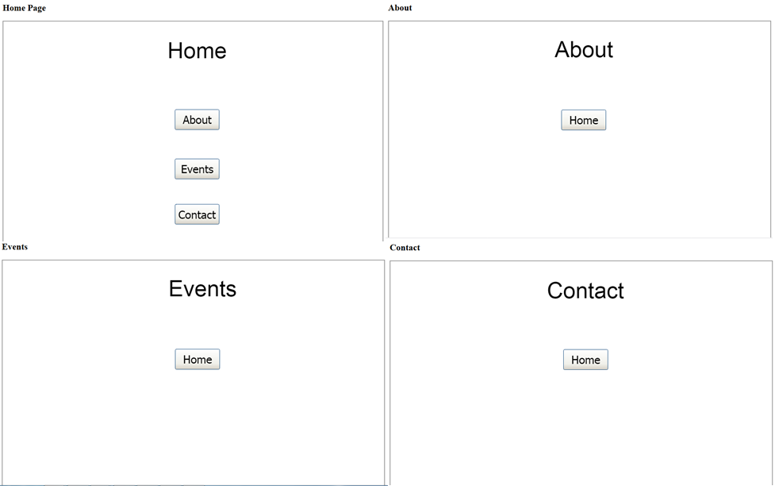

**Please ensure that you demonstrate your completed lab work to the Lecturer or Lab Supervisor before you leave the Lab today.**

You created two files in today’s lab

* lab4-part1-studentNumber.epgz
* lab4-part2-studentNumber.docx

Submit the two files from today’s lab in one Zip file named

* *lab4-studentNumber.zip*

**Upload your completed lab work in the ZIP file to WebCourses before you leave the Lab today to ensure there is a record of your work.**